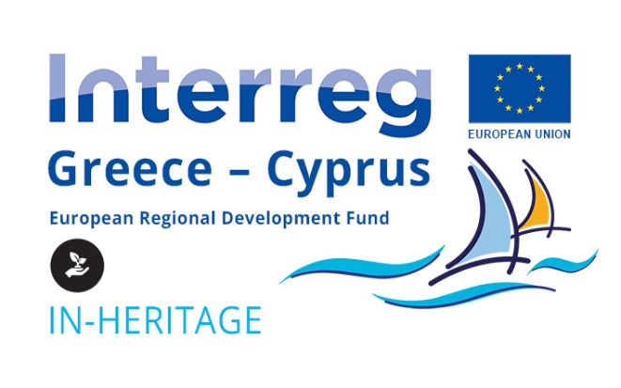

**ACCESSIBLE**

**NATURE & CULTURE**

SUSTAINABLE TOURISM

www.in-heritage.eu

Co-funded by the European Union (ERDF) and by National Funds of Greece and Cyprus

time   
for holidays,   
nature and culture

ACCESS FOR ALL

Improving accessibility for people with disabilities and promoting and exploiting the rich cultural and natural heritage of Crete and Cyprus can offer significant growth potential to local economies, attracting new markets and extending the tourist season.

€1.200.810,00  
Total project budget

€1.020.688,50  
Union support

24 months  
Project duration

The municipalities of Rethymno, Ayia Napa and Sotira, although already very popular tourist destinations, taking into account the international competition, recognize the need to improve the quality of the tourist product, to extend the tourist season and to expand their market share. Thus, they systematically engage in an effort to attract new categories of visitors, such as the elderly and people with disabilities and/or chronic diseases.

The IN-HERITAGE project concerns various interventions of the municipalities aimed to improve the accessibility of their natural and cultural heritage infrastructure, under the guidance and support of the National Confederation of Disabled People from Greece, in order to exploit them to claim their share in the global market of accessible tourism.

culture

access  
for all

The project includes:

* **New accessibility works** at selected natural and cultural sites of the three municipalities, as a follow-up of the interventions that were successfully completed in the previous period of the Interreg V-A Program Greece-Cyprus
* The development of a common **system for assessing accessibility** and awarding a new **special label** “Natural/cultural heritage site accessible for all”
* **Accessibility inspections** at emblematic sites of natural and cultural heritage across Crete and Cyprus for presenting attractive options to interested visitors
* The development of a common **strategy and plan** for the development of accessible tourism and for improving the capacity of municipalities and local businesses in endorsing modern approaches and good practices

**Technical works** funded by the Programme:

* The Municipality of Rethymno will proceed with the renovation of a traditional olive mill and its conversion into an accessible exhibition space, the supply of an electric vehicle to facilitate visitors with mobility limitations at the Venetian fortress of Fortezza and the placement of accessible information signs at selected sites.
* The Ayia Napa Municipality will carry out further accessibility interventions at two beaches of the municipality, at the municipal museum “THALASSA”, at the land area of the port and at event sites of the municipality.
* The Sotiras Municipality, after a study to be conducted, will focus on interventions at the most important event venue areas of the municipality.

nature

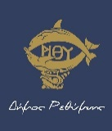PROJECT BENEFICIARIES

(Lead Beneficiary)

Municipality of Rethymno

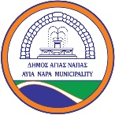[www.rethymno.gr](http://www.rethymno.gr)

Ayia Napa Municipality

[www.agianapa.org.cy](http://www.agianapa.org.cy)

National Confederation of Disabled People, Greece

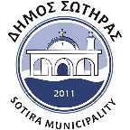[www.esamea.gr](http://www.esamea.gr)

Sotira Municipality

[www.sotira.org.cy](http://www.sotira.org.cy)

CONTACT US

projects@rethymno.gr

Disclaimer: The content of this publication is sole responsibility of the project beneficiaries and can in no way reflect the views of the European Union, the participating countries and the managing authority